Introduction to PowerPoint





**Welcome!**

Welcome to the Introduction to PowerPoint class. Microsoft’s PowerPoint is a program that allows you to create presentations, or slide shows. Slides may contain text, graphics, sound, movies and other objects. The presentation can be printed, displayed live on a computer, or navigated through at the command of the presenter.

By the end of this course, you will be able to:

* Create a PowerPoint presentation
* Add text to slides
* Add slide transitions and effects
* Preview your presentation

There are many aspects of PowerPoint that we cannot cover them all today, but the above list will help get you started creating PowerPoint presentation in a safe and fun environment in our classroom. Please ask questions as you think of them, and be sure to have fun!

**Remember:**

Depending on your software, your screens may vary slightly from the screens shown in this handout. Hopefully this class will help you create presentations with PowerPoint with confidence.

**Let’s Get Started with PowerPoint!**

PowerPoint is a part of Microsoft’s Office suite that comes on most PC computers. Use the **start key** to either search for PowerPoint or navigate by going to **All Programs** then **Microsoft Office** to open the suite. PowerPoint’s icon looks like an orange P. Open PowerPoint.

PowerPoint’s Icon

Undo

Redo

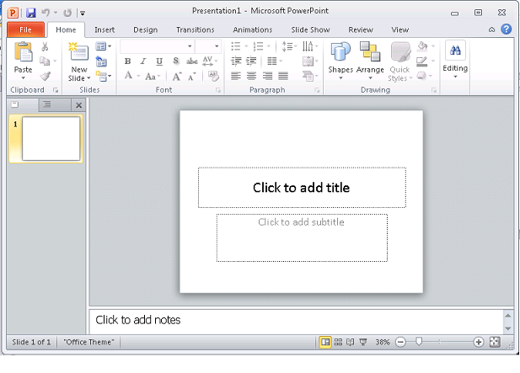

Side bar display of slides

Minimize, Maximize, and Exit

Default slide

New Slide Button

Save Button

* Minimize, Maximize and Exit are located in the upper right corner.
* The Save button, which looks like a floppy disk, is in the upper left corner next to the PowerPoint icon.
* The Undo button reverses the last action or edit made.
* The Redo button next to the undo button repeats the last action taken.
* The New Slide button creates a new slide, usually the default.
* The Side bar on the left displays all current slides and allows for navigation between them.
* The default slide has a title and subtitle where you click to add text.

1. Click to add the title. Type in: “My Presentation.”
2. Click to add the subtitle. Type in: “Created in PowerPoint.”
3. Change the font and text size. Highlight “My Presentation.”

Font Size

Font Face Type

Bullets and Number Lists

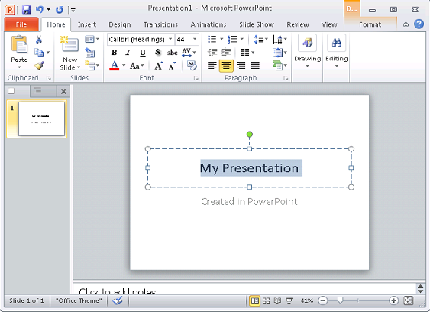

Highlight the text

Paragraph alignment

Text Color

Font section

1. Find the **Font** section and choose a different font size, face type, or color. You can bold, italicize, or underline your text as well. Remember the undo button and explore.
2. You can change the alignment of the paragraph, add bullets or numbered lists from the **Paragraph** section.
3. Click **New Slide** to add a second slide.
4. Similar to the default slide, this one has a title area above a larger main area. Hover your mouse over the different icons. The picture icon allows you to insert a picture from file. You can enter tables, charts, a SmartArt Graphic, pictures, clip art, and media clips. For now let’s enter in text.

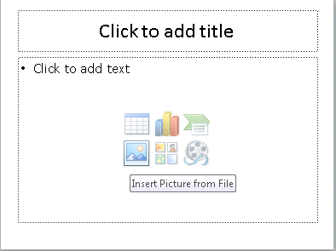

Hover your mouse to see options

Slide Title

1. In the title area, type in: “Grocery List.” Click to add text in the main area. The text defaults to bullets. Type in:

* Milk
* Eggs
* Onion
* Potato

1. Use your mouse to highlight the list you made and go to the paragraph section and align the list to be centered. Change the font to underlined. See above #5 if you need a hint.

Drawing Section

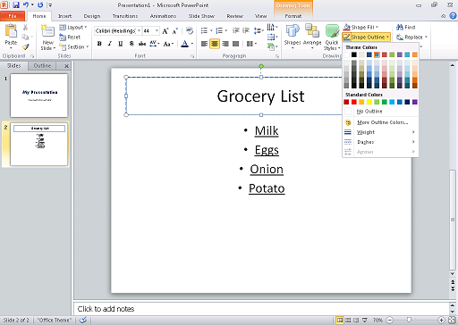

Shape Outline

Title Area

1. Now click the title area again. Find the **Drawing** section and the **Shape Outline** and click it. We’re going to add a shape outline to the title area. You can also fill the shape with **Shape Fill**.
2. Click to the **Transitions** tab. There are many transition types that you can assign for slides. The default is none. You can preview the slide transitions here, as well as the sound, duration and other options. Click **Fade** on the first slide and then preview. You should see your slide fade into view from a black screen.

Other Options

Transition Section

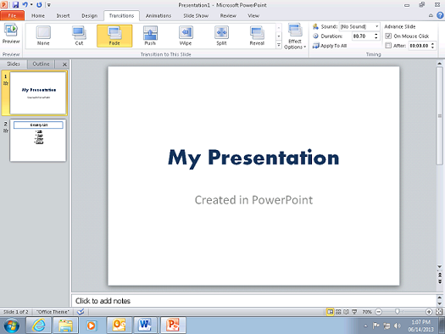

Slide Transition types

Transition Preview

1. Let’s see what we have so far. Click the **Slide Show** tab. This will show the presentation as it currently is, with the timing and slide transitions you’ve assigned. Click **From Beginning** to show a full screen view of your presentation. If you need to exit the full screen, press **Esc** on your keyboard.

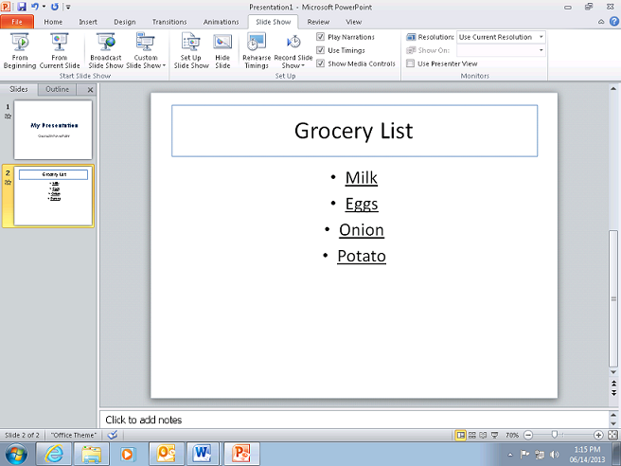

Begin Slide Show from the current highlighted slide

Begin Slide Show from the 1st Slide

Slide Show Tab

Additional: Click the **Design** tab. Here you can adjust the page setup, the slide orientation and the background designs of your slides. In the **Themes** section you can add a theme to your presentation which will change the background graphic, font type, font size, font color, text location, and outline color. You can alter all of those aspects of your presentation after a theme has been used.

There are many aspects of PowerPoint to explore that goes beyond the time frame and scope of this class. We hope that this introduction to Microsoft’s PowerPoint has given you the tools to create presentations of your own!